Comments on supplementary figure 1: the maps

One of the reviewers mentioned that the map color scales were a little hard to read. This is due to an artifact of the distribution of values. Particularly in the total admissions data (large states have a lot more than admissions than small states, so the scale is pushed a lot further out). The number of admissions has an exponential distribution, which makes it hard to fit a linear color scale.

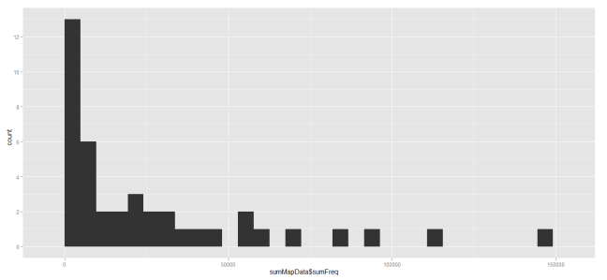

Changes to make the map more viewable:

1. Highlighted the state board outlines. This makes it easier to tell between two states with similar values. This is figure choice 1.
2. Plot the log value of the admissions (Figure choice 2). I personally don’t like this and thinks it makes the data harder to interpret.
3. Blue to yellow scale (Figure choice 3)
4. Red to yellow scale (Figure choice 4)

The same were done for the proportions map. Let me know which you think is the best, and I will send you the higher resolution jpegs for that one.

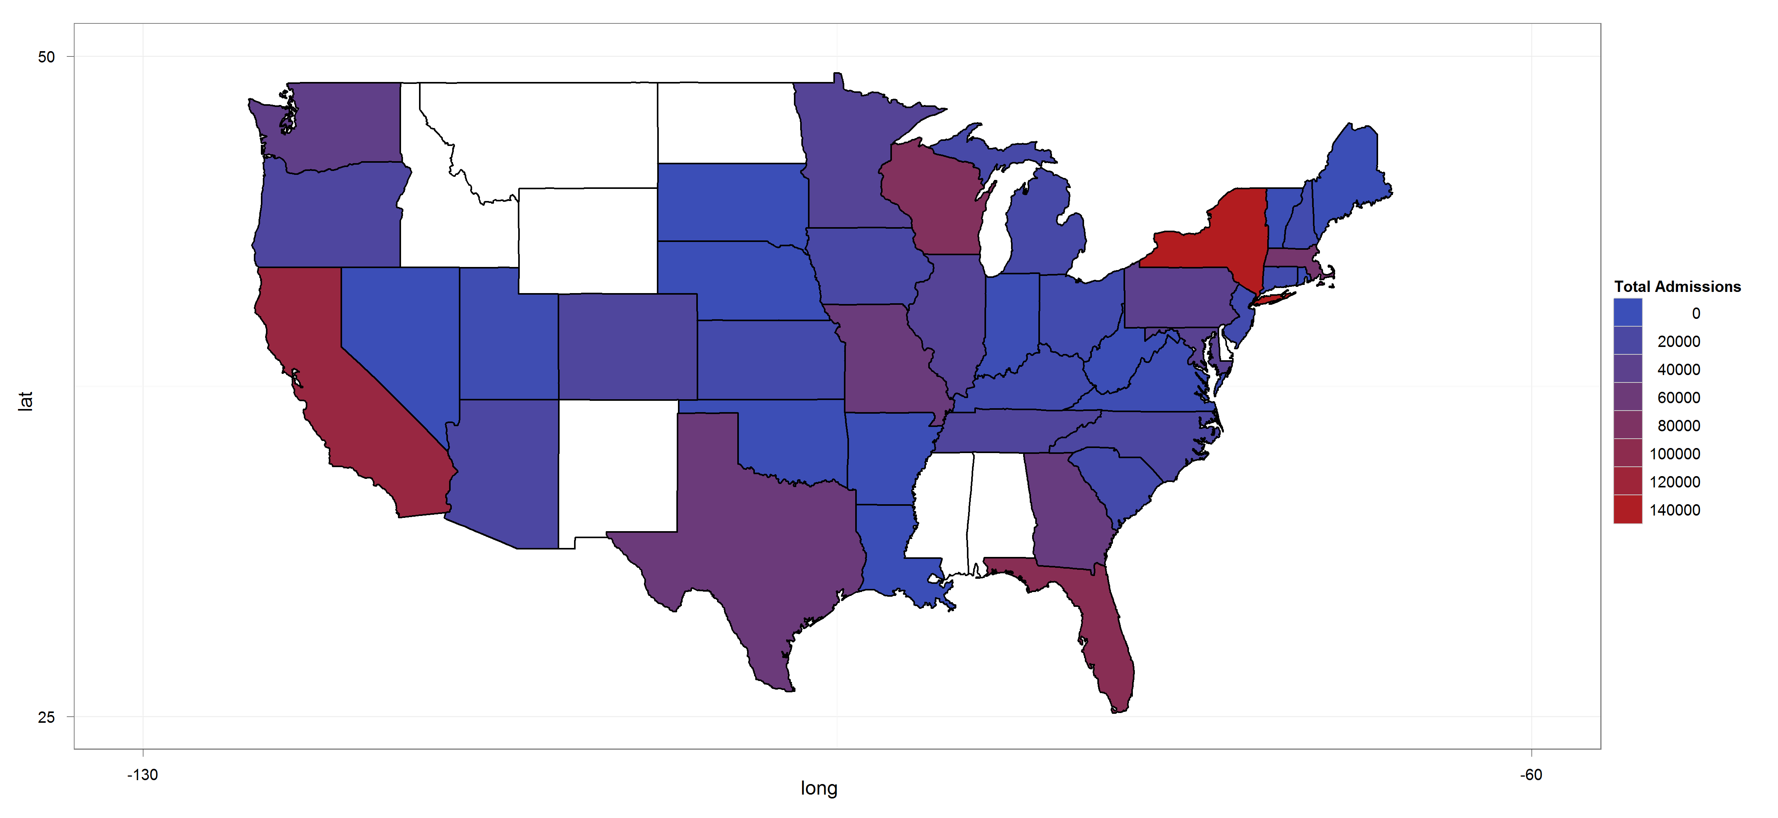 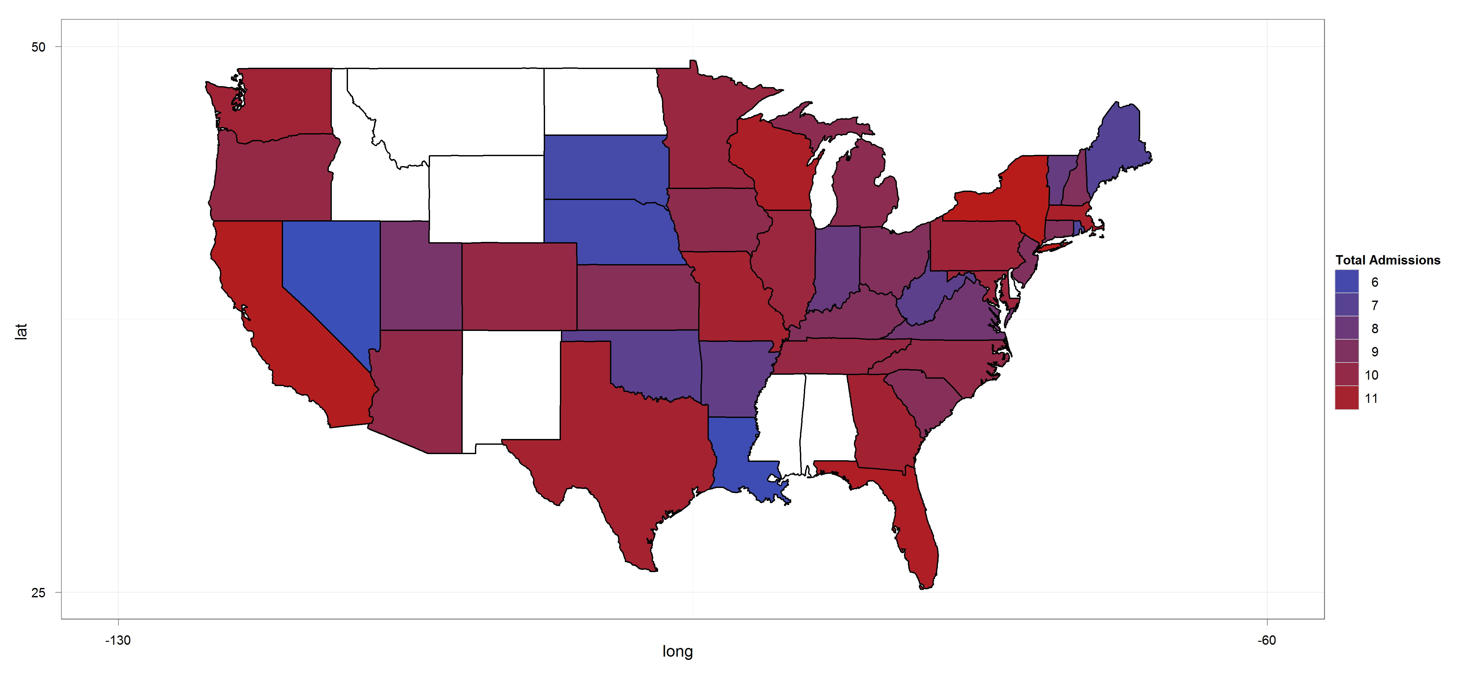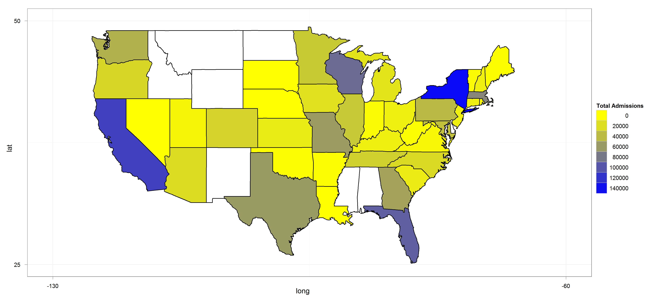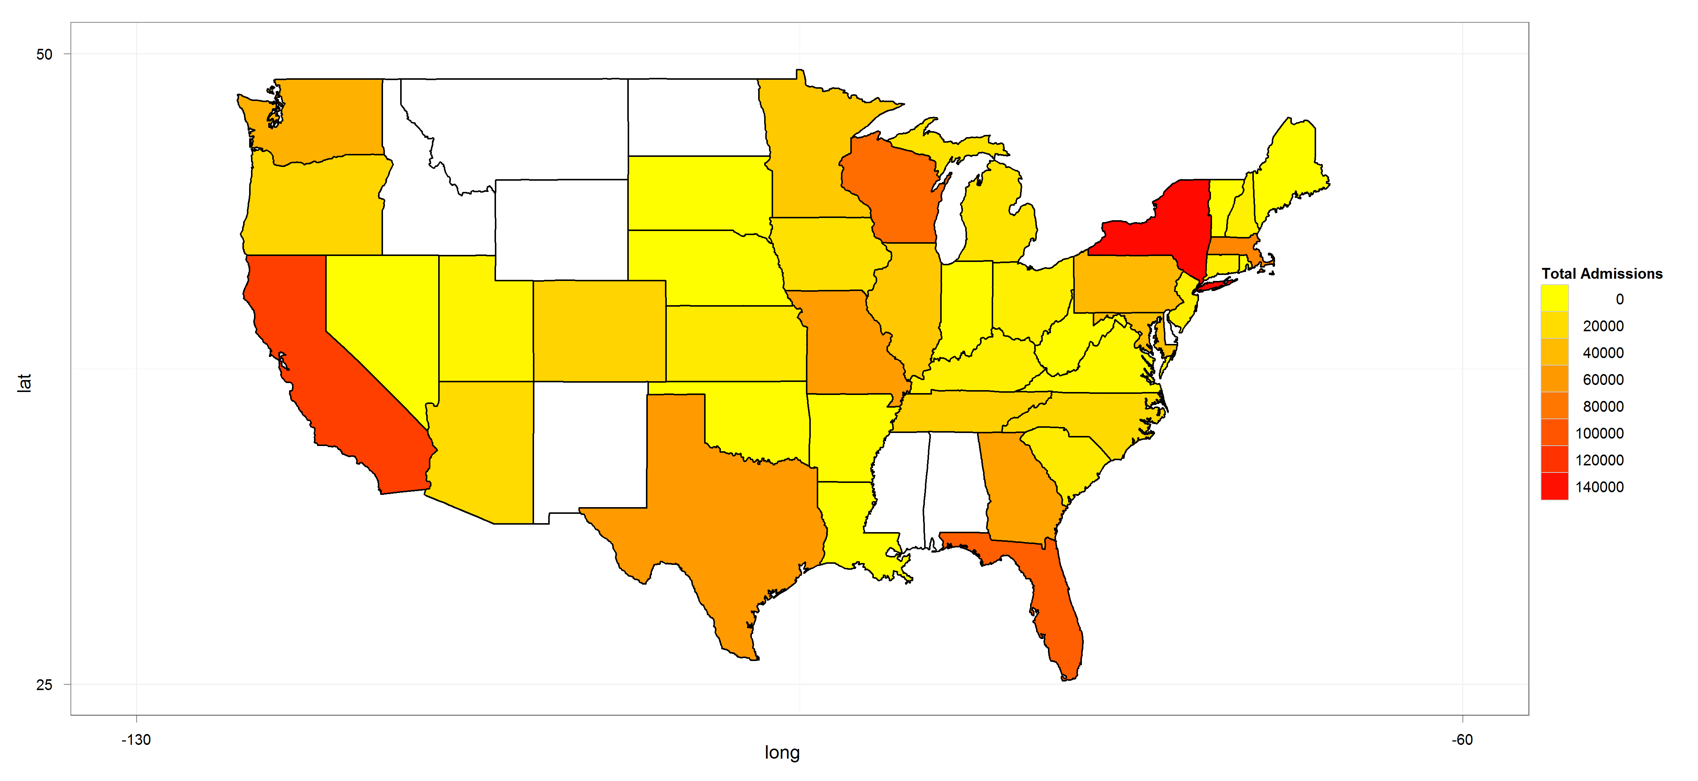

Same for proportion maps

